How to use the Vision® transit seat configurator
Build your own Vision transit seat by visiting http://visualize.americanseating.com/configure/vision

Select the seat type you wish to configure.

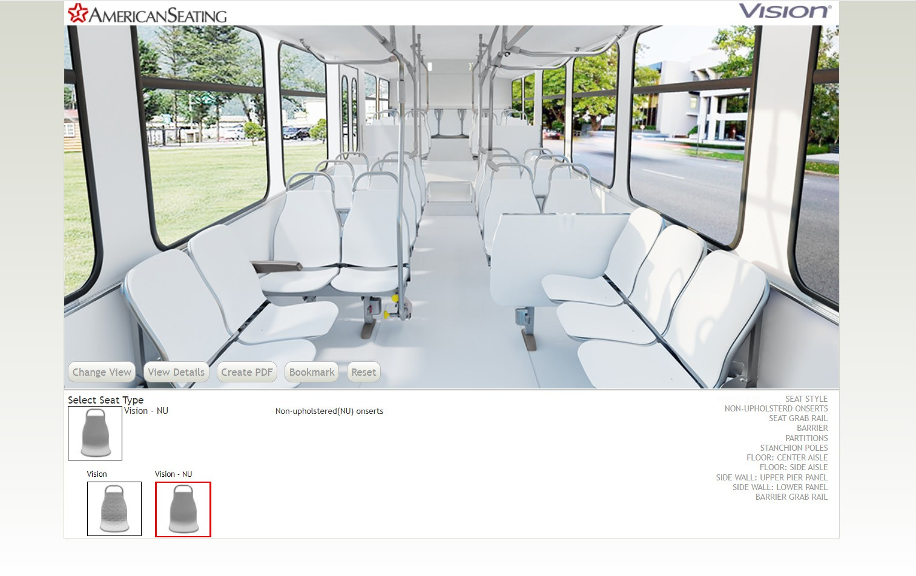
1

- 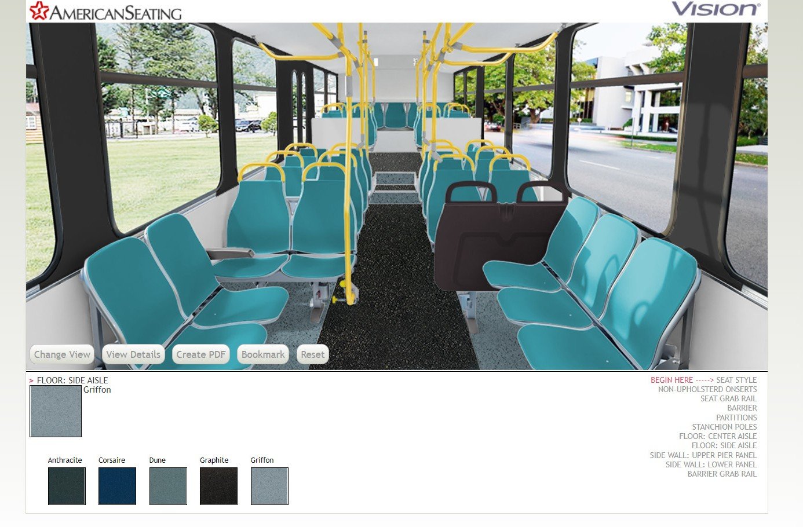Select from a variety of components specific to the chosen Vision seat type.
3
2

- Once the desired components are selected, choose from the following buttons:
- Change View: A large image including the front and back of the two-passenger seat will display
- View Details: Display a list of the selected design options
- Create PDF: Download A print-ready PDF file of the selected design options
- Bookmark: Save a bookmark of the selected design options
- Reset: Remove all of the selected design options

801 Broadway Ave NW, Grand Rapids, MI 49504-4499 Phone 616-732-6600 FAX 616-732-6401 americanseating.com
American Seating is a registered trademark of American Seating Company
©2019 American Seating Company

